Call -> Log4OM de IZ3XNJ

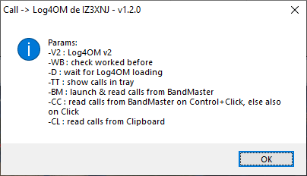

I’ve wrote this utility to retrieve callsigns from:
- FlDigi (http://www.w1hkj.com/)
- BandMaster (http://www.dxatlas.com/bandmaster/)
- JTAlert (https://hamapps.com/)
and send to Log4OM (https://www.log4om.com/).

This utility is written in AutoHotkey, a open source automation scripting language for Windows, you can find more about it at https://autohotkey.com

When using the executable version, you should not need AutoHotkey, but it is free and open source, it do not disturb and it is a great tool for tasks like this one.

My program is open source and available at https://github.com/StefanoComelli/Call2Log4OM

If you need to use my program on 32 bit and you’re not able to recompile it, please feel free to contact me.

The archive Call2Log4OM.zip is composed by:
- Call2Log4OM.ico: icon
- Call2Log4OM.exe: 64 bit executable
- Call2Log4OM.pdf: this help file

Put all files inside a directory.

The executale needs some starting parameter:
- -D: the program wait for Log4OM being completely running
- -TT : show callsigns in Tray Bar
- -BM : launch & read calls from BandMaster
- -CC : read calls from BandMaster on Mouse Control+Click, else also on Mouse Click
- -CL : read calls from Clipboard (i.e. from FlDigi)
- -V2: to use Log4OM NextGen, also know as Version 2
- -WB: check if callsign is worked before

For example, I launch it from Log4OM V1 with this syntax:

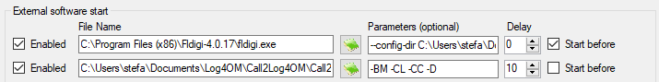

in Log4OM V2:

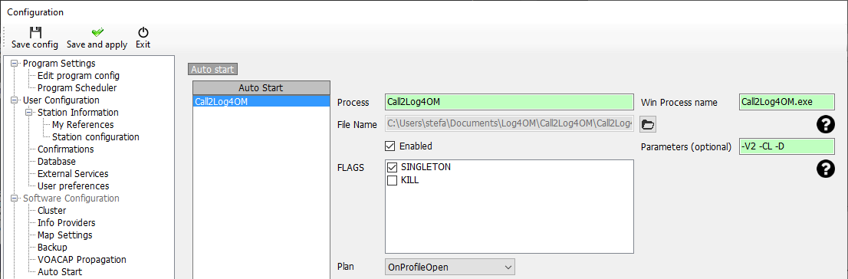

When started, my program waits until Log4Om is fully loaded:

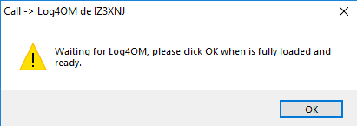

At the beginning, the program does a quick config:
- clear and put a small text into the Callsign field
- retrieve it and clear

If something goes wrong:

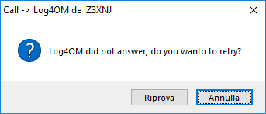

Now the program begin to do his work: everytime you
- in FlDigi, click a correct call in the rx windows, more precisely when the “Call” field is filled
- in JTAlert, right click a callsign an then click “Copy Callsign to Clipboard”
my program should:
- retrieve it
- convert to upper case
- activates Log4OM main window and makes it foremost
- read previous call
- only if new is different from previous:
  - click CLR button to clear previous call
  - paste new callsign from clipboard to the Callsign field
  - only if -WB option is set, push button in Log4OM to retrieve info about previous QSO with the same callsign

Attention: I’ve said “everytime you click a correct call in the FlDigi rx windows… my program should” because FlDigi does some check on the clicked text and sometime it do not recognise a call to be correct. In that case, FlDigi do not copy the call in clipoboard, so you have to copy it manually.

By the way, my program just paste from clipboard what is on the clipboard, no matter if is copied into clipboard by FlDigi or by any other application. In other words, any text copied into clipboard is pasted by my program. At least, my program check if this text is longer than 3 chars and shorter than 13 chars, but at the moment it don’t check more than this.

In BandMaster, everytime you click (or Control+Click) a spot, my program
- retrieve it
- activates Log4OM main window and makes it foremost
- read previous call
- only if new is different from previous:
  - clear previous call
  - paste new callsign from clipboard to the Callsign field
  - only if -WB option is set, push button in Log4OM to retrieve info about previous QSO with the same callsign

There is no need to stop my program, as it checks every 5 seconds if Log4OM is still running, so when you stop Log4OM my program terminate himself.

Anyway, my program put an icon on tray, so there is a menu where you can choose to exit or to look at a quite simple about function.
The Config menu just repeat the config startup process.

If you need some help, feel free to contact me.

IZ3XNJ Stefano
iz3xnj@gmail.com

